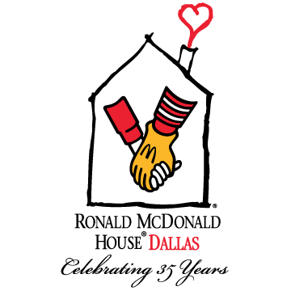

2015 FACT SHEET

Mission
Ronald McDonald House of Dallas supports the health and well-being of seriously ill or injured children receiving treatment in the Dallas area by providing them and their families a home-away-from-home.

About Ronald McDonald House of Dallas
With approximately 60,000 square feet, the House offers 52 private bedrooms and six transplant apartments. Additionally, the House contains multiple playrooms for kids of all ages and interests, a library, media room, craft room, chapel, meditation garden, and outdoor play areas. Two large communal kitchens and dining room provide opportunities for the families to share meals, which are provided 3 times a day by community volunteers, or to prepare their own food if they choose.

Hundreds of volunteers support RMHD’s annual operations and fundraising activities by serving
families at the House, preparing meals, and hosting organized activities. In 2015, over 14,500 volunteer hours were donated equaling a value of $339,936.

Since opening its doors, the Dallas House has served more than 36,000 families. Although families are asked to contribute $15 per family per night, no one has ever been turned away because of an inability to pay. The actual cost per night to house a family is approximately $125— a cost largely covered by individual and corporate donors, community organizations, and special events.
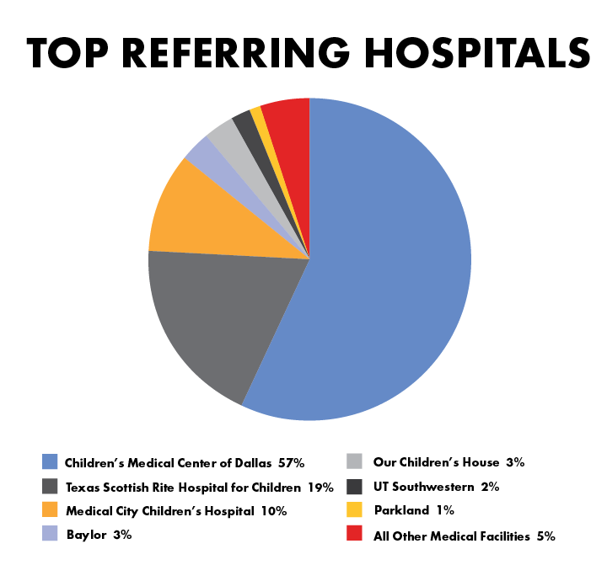

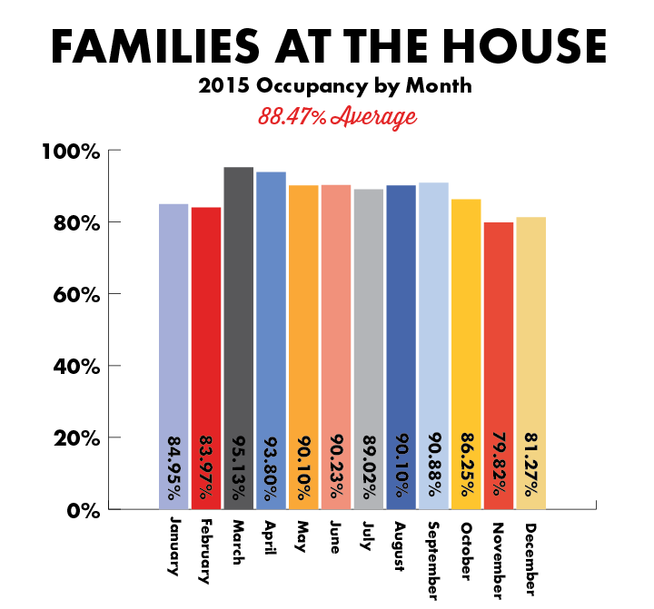
Who We Served in 2015
- Nearly 1,200 families were served totaling
18,406 night stays in the House
- Guests traveled from 14 countries
and 27 states
- Average length of stay, 15.5 days
- Average monthly occupancy rate, 88.47%
- A wide variety of referred diagnoses including
cardiology, orthopedic, oncology, premature birth,
neurology and more

Funding
The Ray Kroc Foundation, now called Ronald McDonald House Charities, provided the initial $25,000 grant to start the building fund for the Dallas Ronald McDonald House. The remainder of the funds raised to complete the present facility came from gifts made by the Crystal Charity Ball, foundations and corporations and from concerned individual contributors. Ronald McDonald House of Dallas is not owned by the McDonald's Corporation or by any hospital or health care organization. Funding to sustain the Ronald McDonald House of Dallas comes from individual and corporate donors, community organizations, and special events. 3.10% of the annual operating budget comes from McDonald's Corporation and Ronald McDonald House Charities of Greater North Texas.
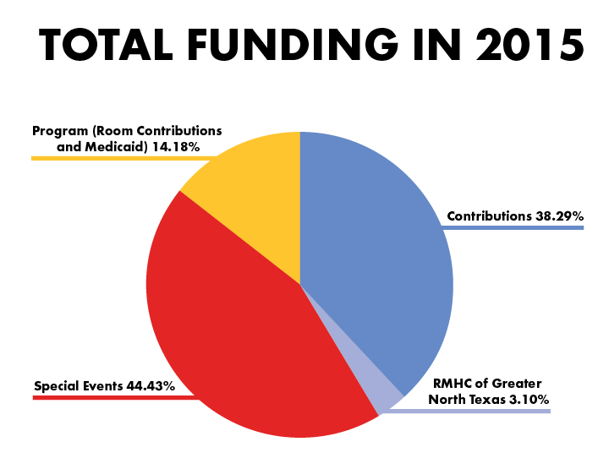
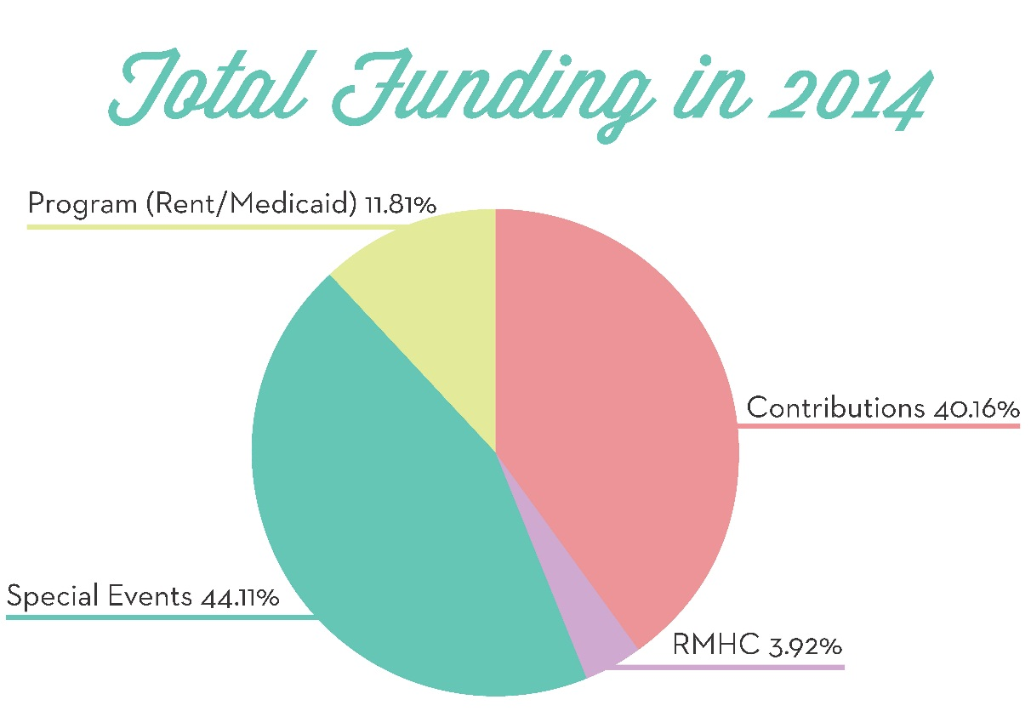

Ownership and Operation
Every Ronald McDonald House is autonomous and is owned by a not-for-profit corporation in the city in which it is located. Ronald McDonald House of Dallas opened in 1981, and today is governed by a board of directors composed of physicians, representatives of area hospitals, community leaders, local McDonald's owner/operators, parents and other interested friends. The Dallas House is administered by a Chief Executive Officer who is supported by a diverse and talented staff. More than 100 weekly volunteers also aid in the daily operation of the House.

Today, Ronald McDonald House Charities is a global mission, with 358 houses in 42 countries and regions; 179 of those are in the United States.

